Evaluation report HGO4011 Autumn 2025
Course convenor: David Jordhus-Lier

The course serves as the foundational introductory course within the MA program in Human Geography. It is a 10 credit course, and a compulsory course for all MA programme students. It is designed to engage students with critical questions surrounding the philosophy and methodology of geography in an accessible and applied fashion. In the autumn of 2025, 25 students registered for this course. David Jordhus-Lier was course convenors, with guest lectures by Per Gunnar Røe, Bjørnar Sæther, Antonis Vradis and Andreas Forø Tollefsen. Attendance in learning sessions is compulsory.
For some years, it has had as its central theme ‘borders’, and used this theme to connect different sub-disciplines, facilitating a comprehensive understanding of contemporary geographical debates. The course aims to foster active participation, critical thinking, and a strong grasp of relevant literature, preparing students for advanced study and research. It is not formally a part of the MA thesis process, but does contain one “Topic development” seminar that precedes the HGO4090 seminars from the second semester an onwards. During this seminar, students get to pitch their ideas in group tutorials. Per Gunnar Røe, Ingar Brattbakk, Antonis Vradis, David Jordhus-Lier and Andreas Forø Tollefsen acted as tutors.
Previous evaluations have indicated that the course fosters high levels of student engagement and understanding through a well-structured curriculum that promoted active participation and critical analysis. Poins for improvement has included better feedback mechanisms from students to course convenor, more peer-to-peer learning and more time spent on unpacking complex concepts.
The 2025 version of the course introduced a “role play seminar”, a reflective journal for students to track their own learning, and more “slow reading” such as reading out loud together. The evaluation was conducted by Mentimeter in class. Most gave the theoretical and conceptual learning outcomes a high rating, whereas the practical learning outcomes (writing, reading and conversation) a fairly high rating. The curriculum, lectures, group exercises and class discussions all rated very high, while the reflective journal was only given a moderate rating.
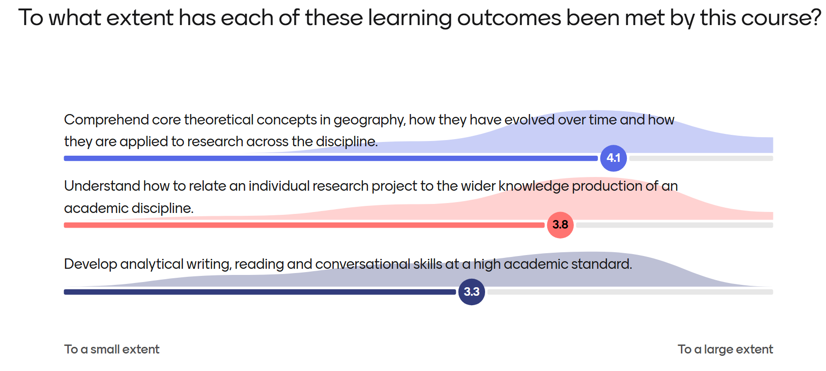
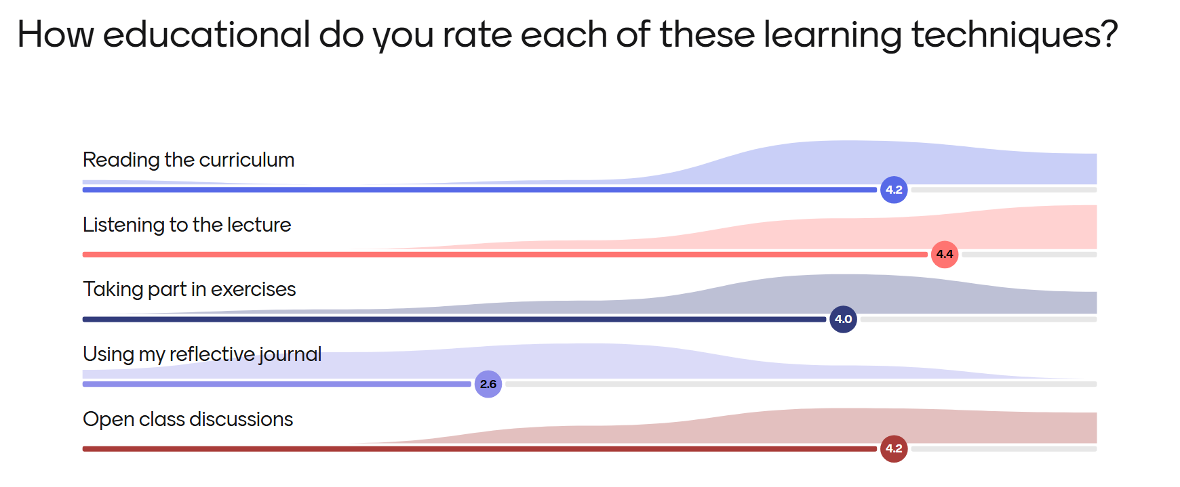
Constructive criticism included ensuring a better consistency between guest lectures and the seminars led by the course convenor, including homework or other preparations to a larger extent, spending more time on ontological and epistemological concepts, and a more hands-on preparation for the home exam. Some also found the focus on AI excessive (this was a semester where all study programmes had to incorporate new guidance to students about responsible AI practices).
There were many positive overall comments about the course in its new iteration, and many underlined that the reflective journal had been useful (even though it received a low score). Other positive comments mentioned by more than one student included reading out loud together, using role play, the use of innovative teaching techniques, the quality of the readings and the hands-on approach to the philosophy of science.

