Guide for the candidate, opponents and the chair of defence at a digital trial lecture and public defence:

Room: Find a suitable room. There should preferably be no windows in the background, no visual disturbance (pictures, lamps ect). A plane room with a clean wall is the best. (The public defence is open for everybody, and there is no guarantee that no one will take a screenshot, so be aware of your background, see example with family picture)

Camera: The camera or web-camera should be at a parallel height as the face, not below or too high. This is especially important to notice if you are using a laptop or an ipad. The distance between the camera and you should be approximately between 60 to 80 cm. Please see picture for demonstration.

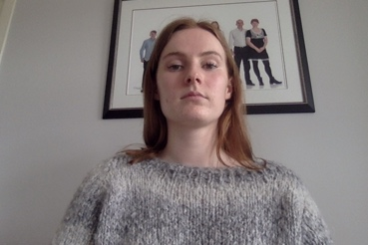
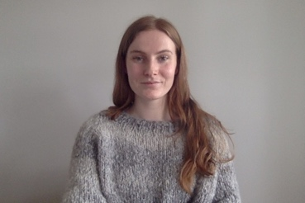

Zoom: When you log in on zoom, click on the «Join Audio» button down to your left, to be able to hear and speak to the other participants:

Mute: The host will mute the audience for any sound disturbance, but not the active participant. The candidate, the opponents and the chair of defence needs to mute themselves. Therefore, be aware of other sound disturbance, like telephone ringing, other people walking in, emails ect if your mute button is not on. Zoom will shift the person on full screen by where there is sound (or by who is talking), therefor it is important to be aware of your background sound. The mute button is also down to your left:

Sound: For best sound quality, we recommend to use headphones, in order to avoid sound feedback.

PowerPoint: To use PowerPoint on Zoom, you need to share your screen. Click on the green «share screen» button and then «desktop 1». Your desktop is now visible for everybody, so be aware of what contents is up on your computer. Open and start your PowerPoint presentation as usual. When you are done with your PowerPoint presentation, please remember to «unshare» your screen.
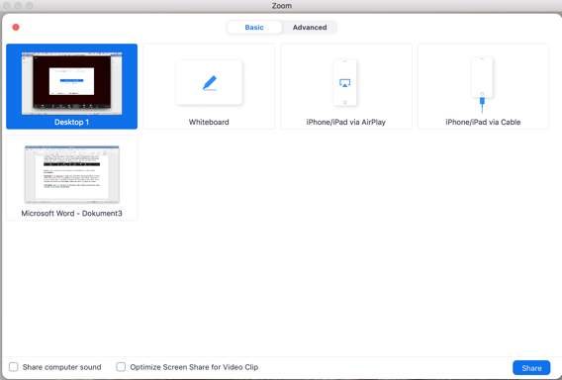

Click “Stop Share” to unshare the screen.
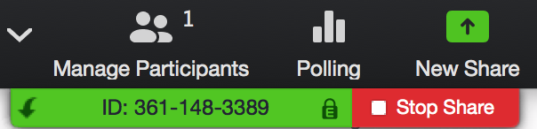

Public defence: Zoom will shift who is on full screen by who is talking at the moment. Please be patient and do not talk at the same time as others.

Co-host: The chair of defence will get the co-host role. The co-host can also mute and unmute, people if necessary. Click on “Manage participants”.

All participant will then appear in the white box to your right.
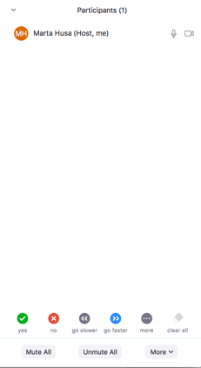

Take the mouse over the name that you want to mute and click on “mute”


Raise hand: Any ex auditorio who want to serve as an opponent need to raise hand. To do so click on participant and thereby the blue raise hand button.
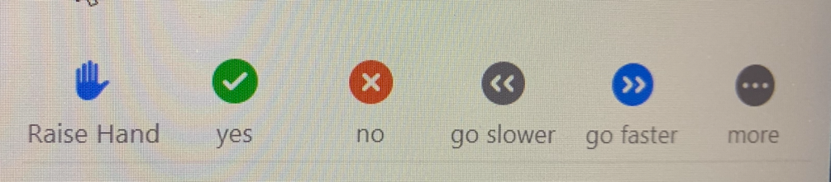

A blue icon will appear by the name of the one who wants to serve as an ex auditorio.
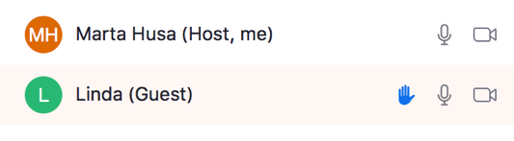

Breakout Rooms: The committee will be assigned in a breakout room in zoom by the host between the trial lecture and public defence. In this room only, the committee can discuss the trial lecture.

